No-IP DDNS Set Up
First of all,you should to know if you want to get a free DDNS domain.The DDNS include some kinds of type domain. So I’m use apply for a No-IP domain for example and for you reference.

(1).Apply for a No-IP domain
No-IP website：http://www.No-IP.com/
Open it then you will see a picture as below：
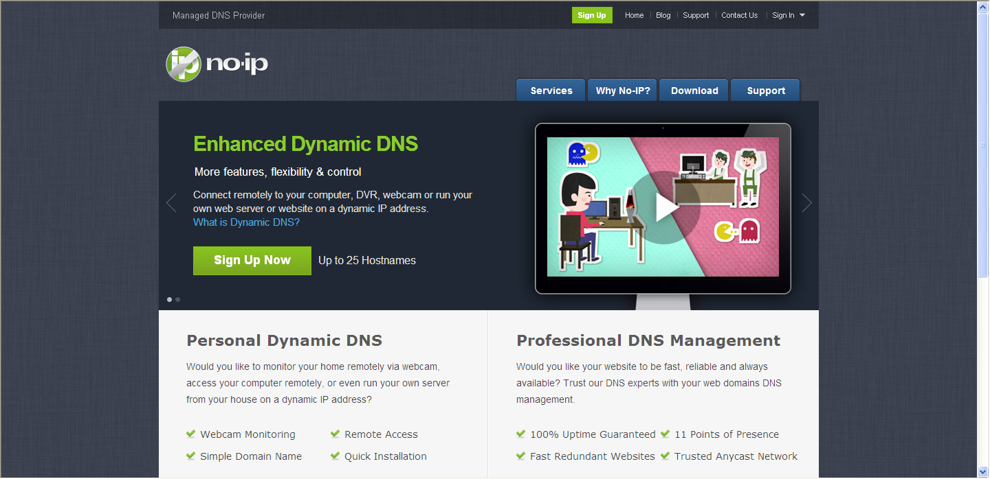
If you ever login a user name and password. You only need sign in. 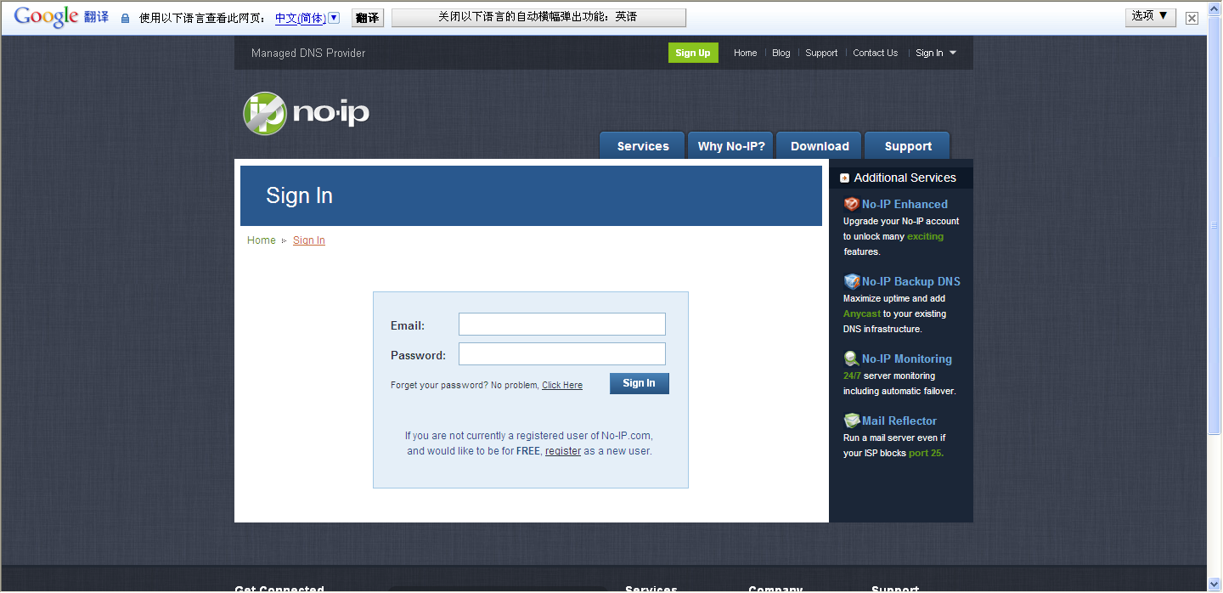
If you never register in at before, please click：Create Account choose Free DNS ,Then enter the register in interface.
2. The registration screen as shown in figure：
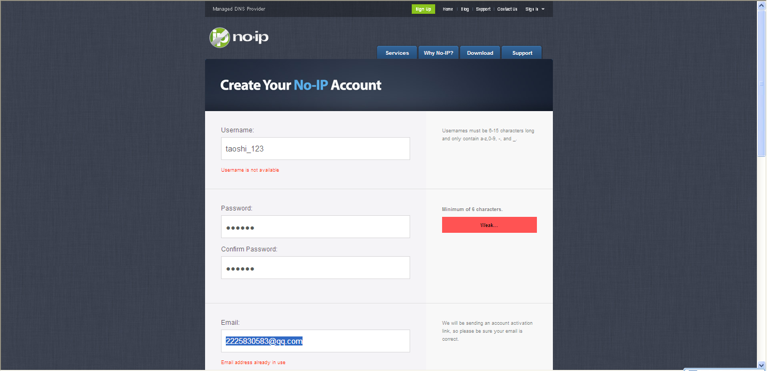
Username：
Password：
Confirm password：
Email：
Hostname：domain name（To become the first domain name, the account can be opened three free）
When above blank you filled with，you should click the Sign up .It means you have finished the first step operating.

3、Second, log in you own email and activate your register username.
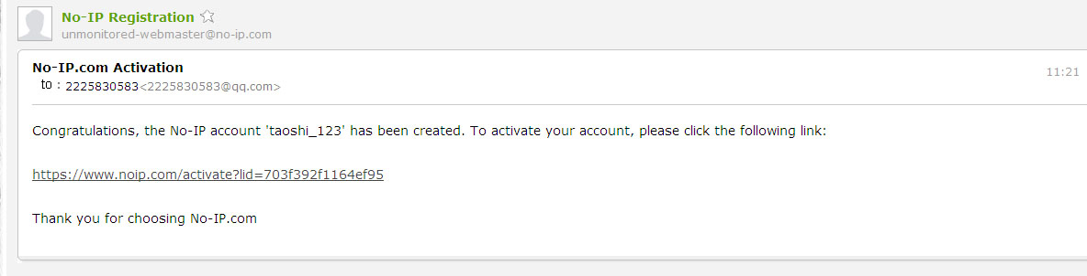
Enter the NO-IP log in interface: 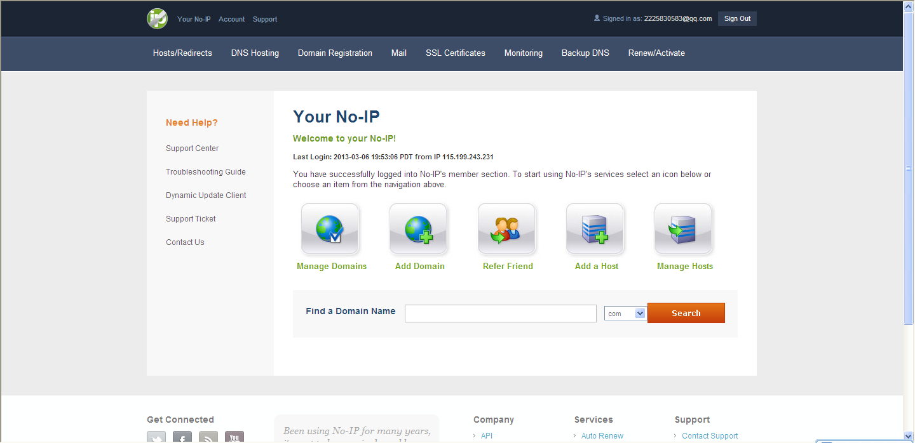
After entering your own space, you should apply for you own free domain name.Click the Picture named Hosts/Redirects
4、Selet red box identification item: Hosts/Redirects,Enter into Hosts management interface

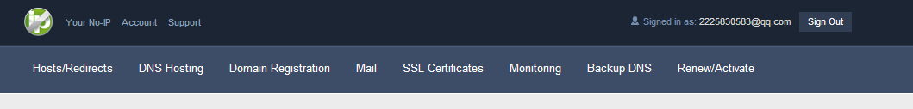

5、Now, the account include a registeration account what is the first free domain you have set up . You can use this free domain to process the DDNS. You also can Register other domain names.

Annotation: The free domain have a limit time.
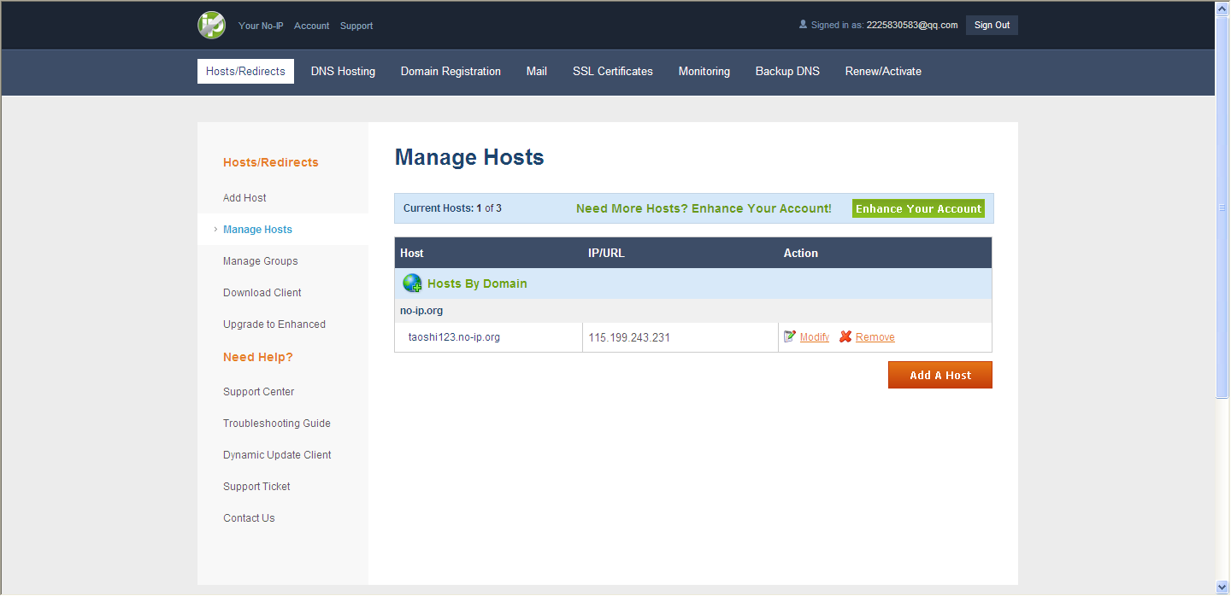

(2)、How to set up DDNS
Please find Menu/Web serve/DDNS. Then select the No-IP. Pitch up the start using.As below picture:
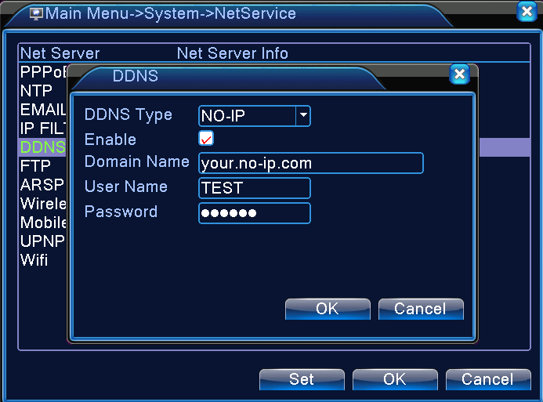
Local domain name: fill in you own domain name what you have register in the No-IP.
Here we use taoshi123.no-ip.org domain name for example.
Local domain name：taoshi123.no-ip.org
User name：use you No-IP user name, testing of user name is taoshi_123.
Password：the password is your No-IP user name’s password.

When you have set up, please use taoshi123.no-ip.org to checkout the setup is successful or not. If ping return true.It means you have set up successfully.
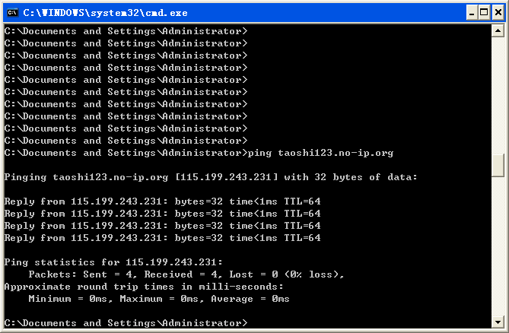
Later you can use http:// taoshi123.no-ip.org/ add the mapping port number to visit the device(Confirm the router mapping was set and the router mapping set see router mapping.
The port mapping can manual addition and by UPNP to automatic acquisition.
Annotation：If you use UPNP function, please confirm the rounter supports.
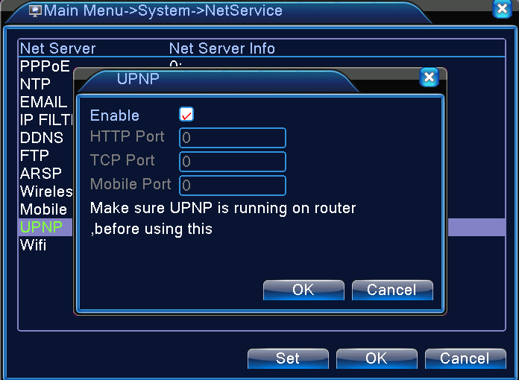
After enabling，you can get HTTP,TCP and Mobilephone surveillance port.
Local DVR UPNP will get HTTP port:81 TCP port:34569
Annotation :Please do not repetition with other device, The UPNP of TCP port and network set up of TCP port should be fit with. If conflict, please firstly modify network port of TCP port.

(3)Via domain name http:// taoshi123.no-ip.org:81 to visit the device
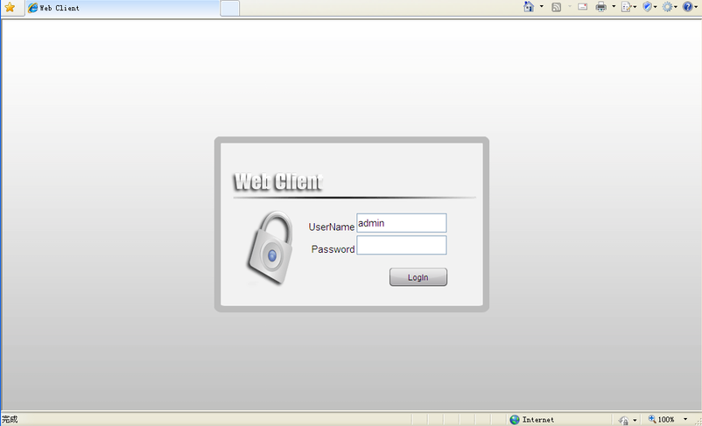

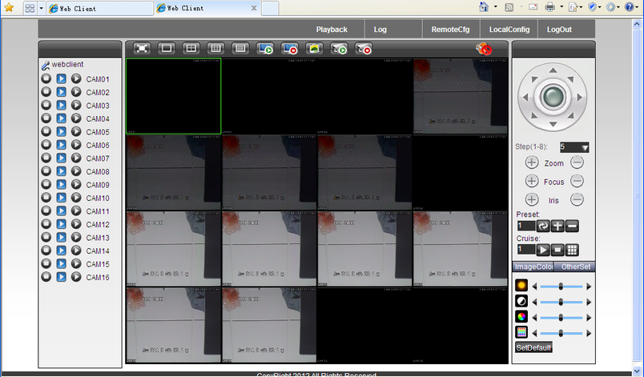

Notice：Test accout :no-ip
Domain names: taoshi123.no-ip.org
User name: taoshi_123
Password: taoshi

